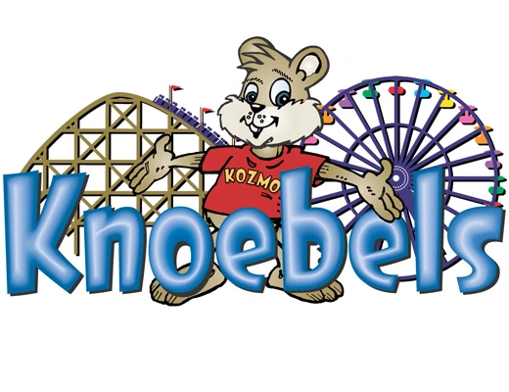
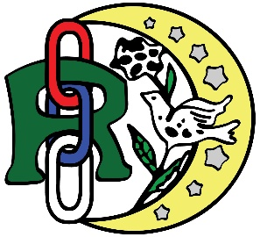


IOOF Knoebels Picnic
July 25, 2026
Pavilion “S” Lunch at Noon

Name / Lodge: _____________________________________ Phone #________________

Adult Meal includes: Hamburger & hot dog, baked beans, macaroni salad, cookie
$12.00 also includes a book of ride tickets.

Kid’s meal includes: Chicken Tenders _____ or Hamburger _____ or hot dog ______
Mac & Cheese, Apple Sauce, chips and cookie $6.00 Check what entrée you would prefer

Kids 15 & under receive 3 ride ticket booklets

Water, iced tea, lemonade will be provided free of charge. If you would like soda, please feel free to bring it.

Adult meals: _______ @ $12.00 = $ _________

Kids meals: _______ @ $6.00 = $ _________

Kids tickets (no meal) __________

Discounted Books of Ride Tickets #__________x $4.50 = $____________

Total Due …………………………………………$_______________

Make Payment to: IOOF PA Jurisdictional Youth Committee

Mail to: Kathy Barber
5503 Buffalo Road
Mifflinburg, PA 17844
Please call if you have any questions: (570) 765-0629

Since we are now required to pay prior to the picnic…
Order and Payment must be received no later than July 1st.
NO EXCEPTIONS! NO REFUNDS.
Event held rain or shine

